**CTEC 3350  
Web Communication Design and Development 2**

**Flexbox – flex-basis: \***

Screenshot 1

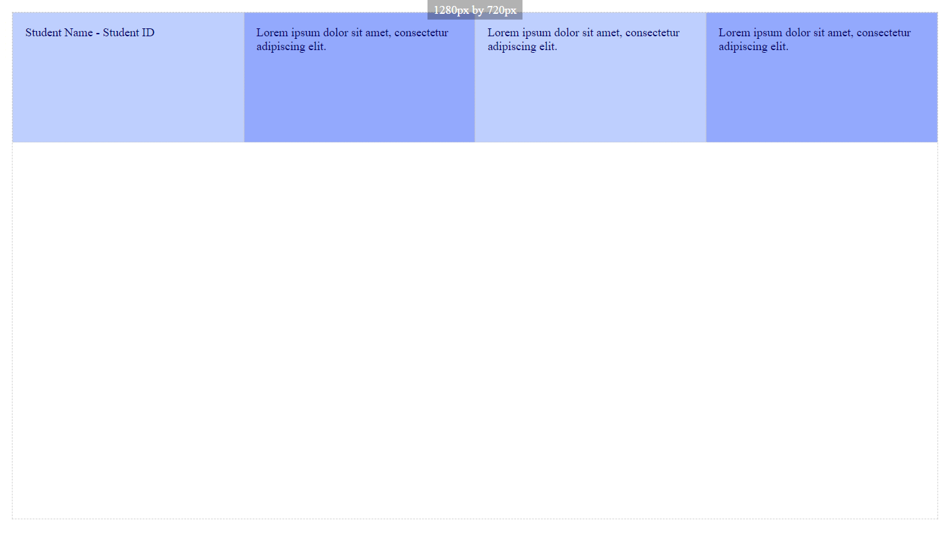

Paste a copy of your screenshot including your Student Name and Student ID (here)

Paste the style declaration you used to make your screenshot happen.

flex-grow:   
flex-shrink:   
flex-basis:

Screenshot 2

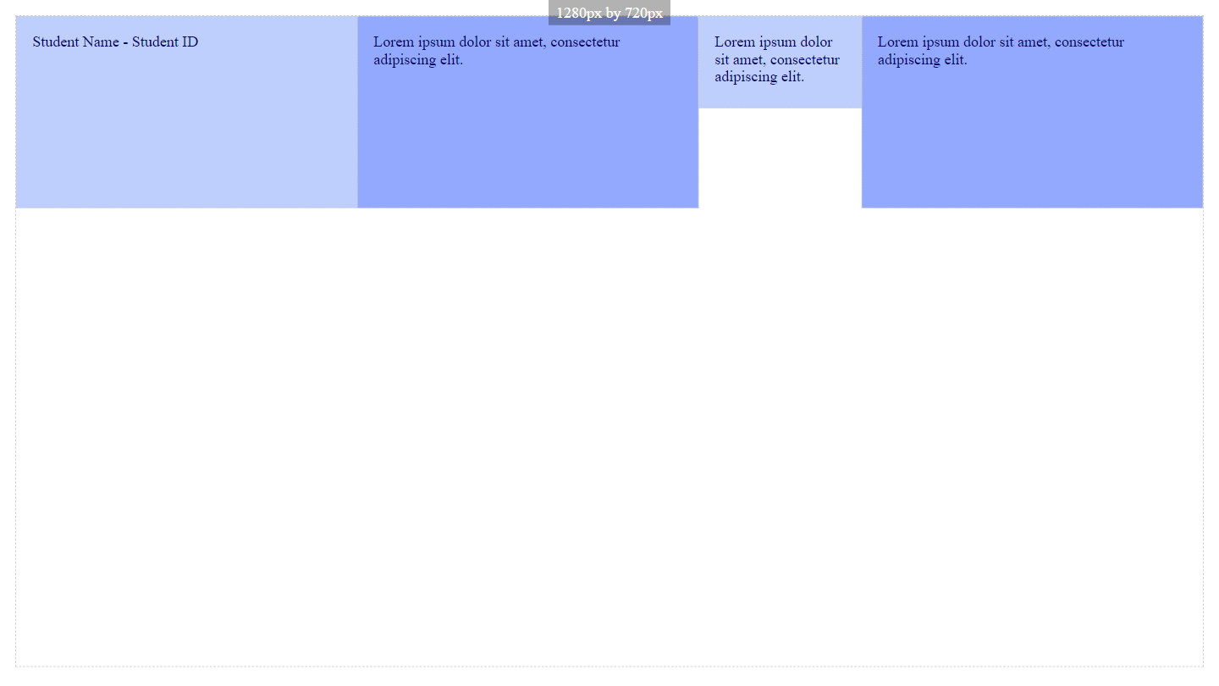

Paste a copy of your screenshot including your Student Name and Student ID (here)

Paste the style declaration you used to make your screenshot happen.

flex-grow:   
flex-shrink:   
flex-basis:

Screenshot 3

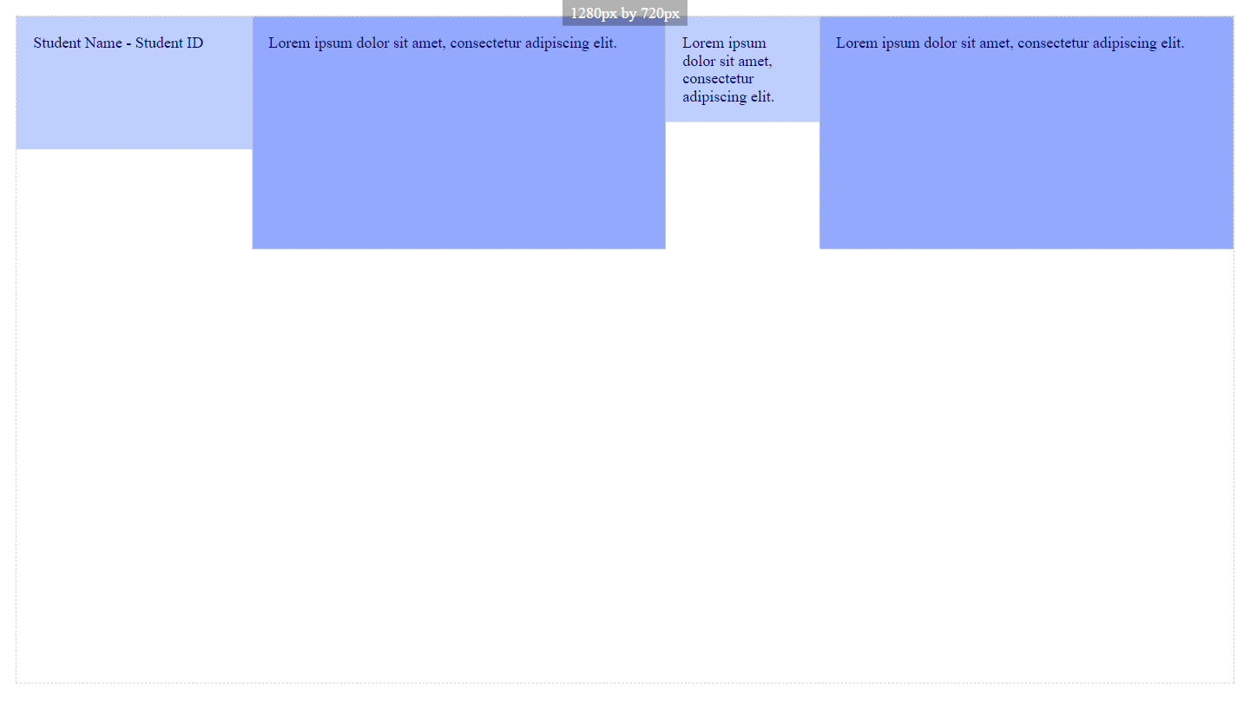

Paste a copy of your screenshot including your Student Name and Student ID (here)

Paste the style declaration you used to make your screenshot happen.

flex-grow:   
flex-shrink:   
flex-basis: